# NEWS TRACKER APPLICATION TEAM ID : PNT2022TMID49399

[**SETTING UP APPLICATION ENVIRONMENT**](https://careereducation.smartinternz.com/Student/guided_project_workspace/7918#collapse1)

**Create Sendgrid Account**

**Step 1:**

Navigate to https://sendgrid.com



**Step 2**:

Click on “Start for free” and register yourselves by entering required details and click on create account

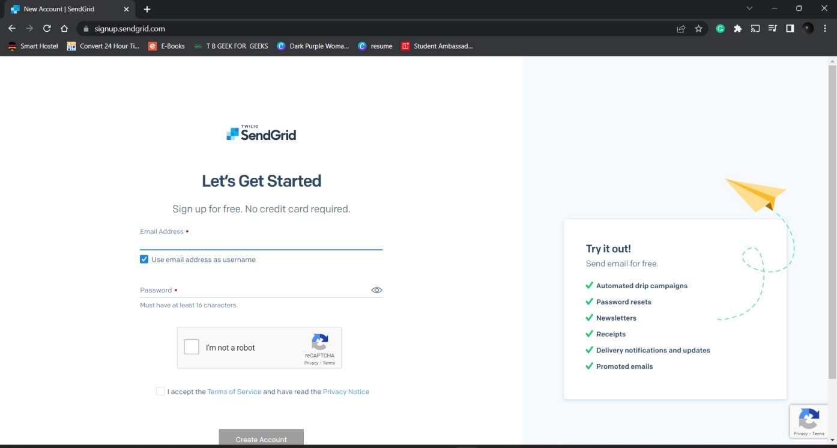

# NEWS TRACKER APPLICATION TEAM ID : PNT2022TMID20111

**Step 3**:

That’s it you have created your SendGrid account and got access to dashboard

